Lesson 02 Demo 06

Implementing an Azure Policy

Objective: To implement Azure policies to enforce compliance and regulatory settings
Tools Required: None

Prerequisites: None

Steps to be followed:
- Assign a policy
- Create and assign initiative definition
- Check for compliance

Step 1: Assign a policy

- Open the lab, login to the Azure Portal and search for Policy

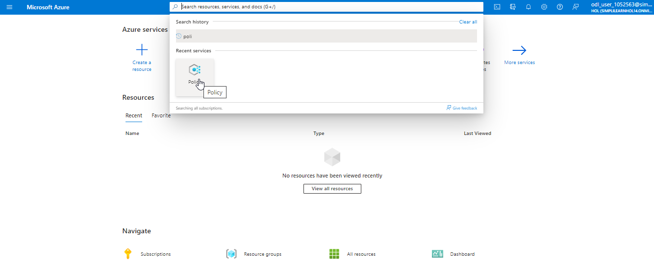

- On the Policy page, select Assignments

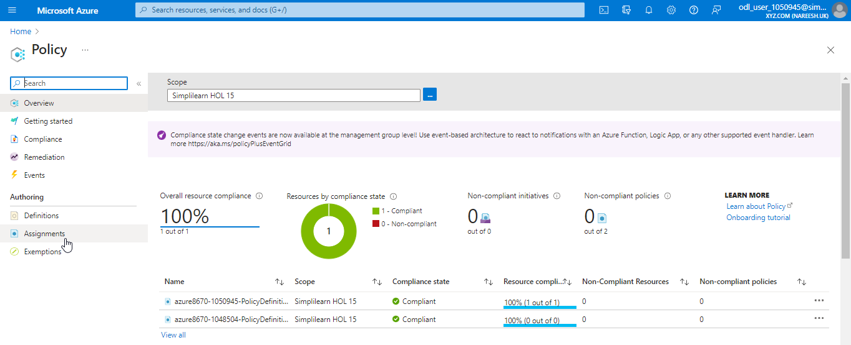

- Click on Assign policy

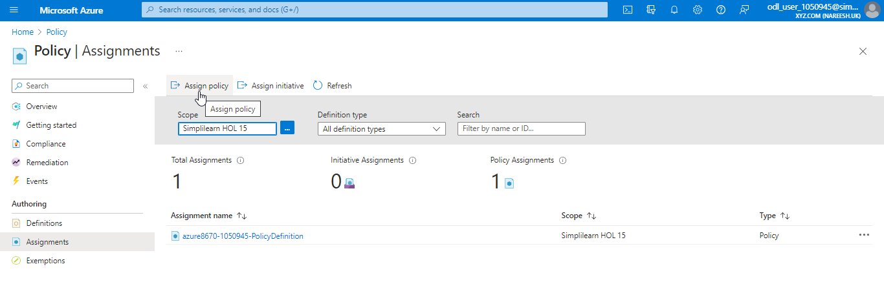

- Under the Assign policy, take note of the Scope. The Scope defines the specific resources or groups of resources on which the policy assignment will be enforced.

- Select Policy definition; this will open the list of available definitions. Take a moment to review the built-in policy definitions.

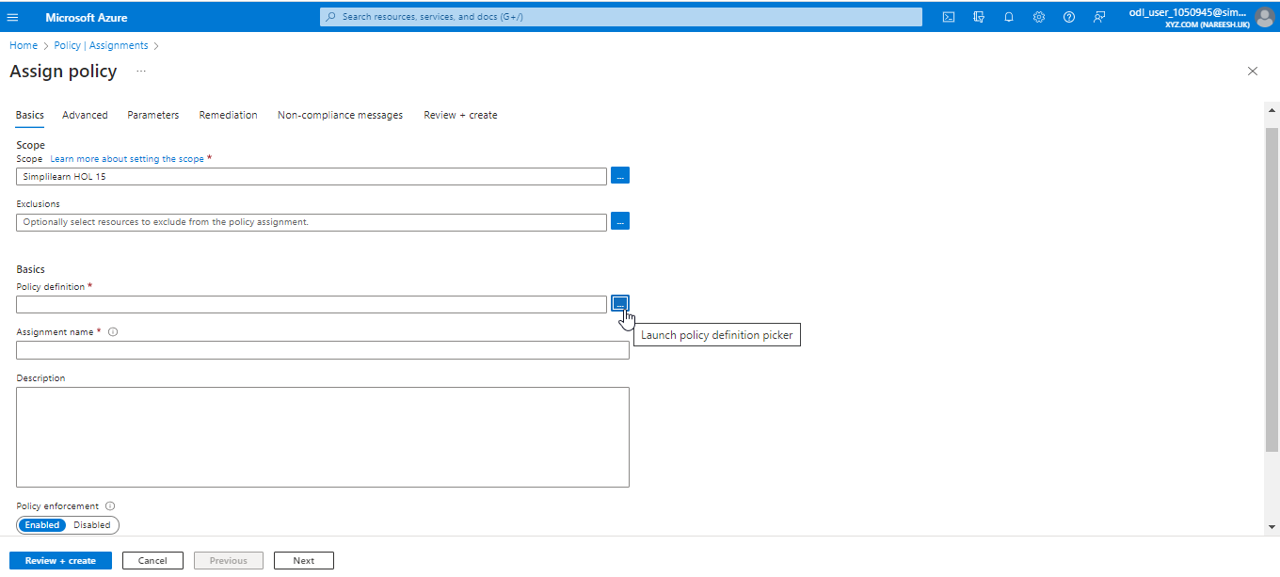

- Choose Allowed locations. This policy allows the user to restrict the locations that their organization can specify when deploying resources.

- Click on Add, then proceed by clicking Next twice.

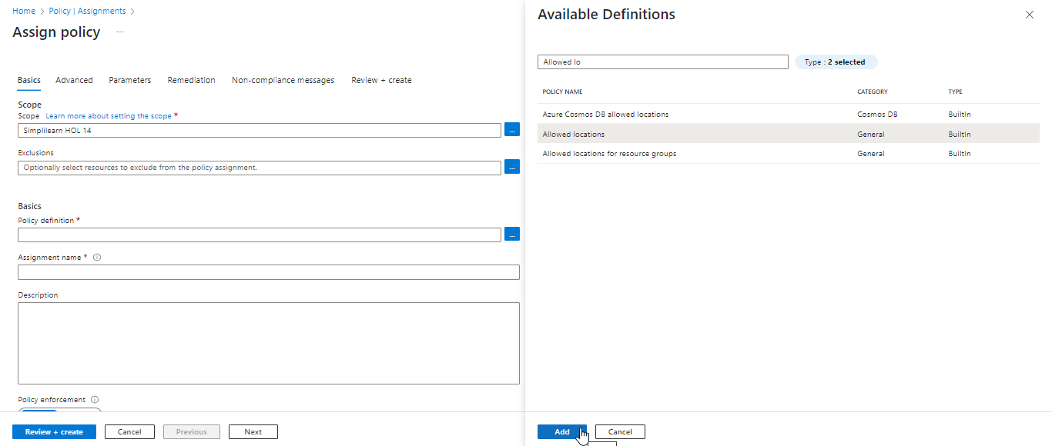

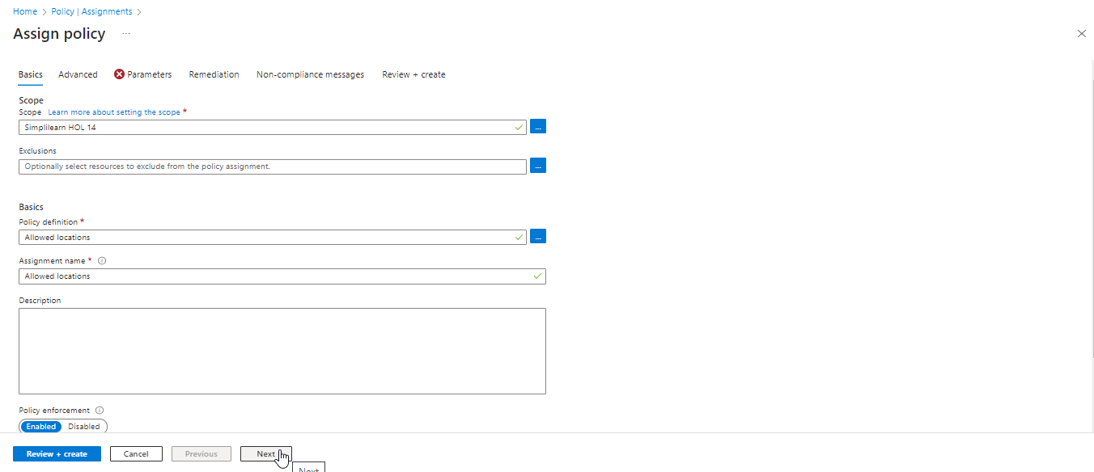

- In the parameter section, choose the Allowed locations and click on Review + create

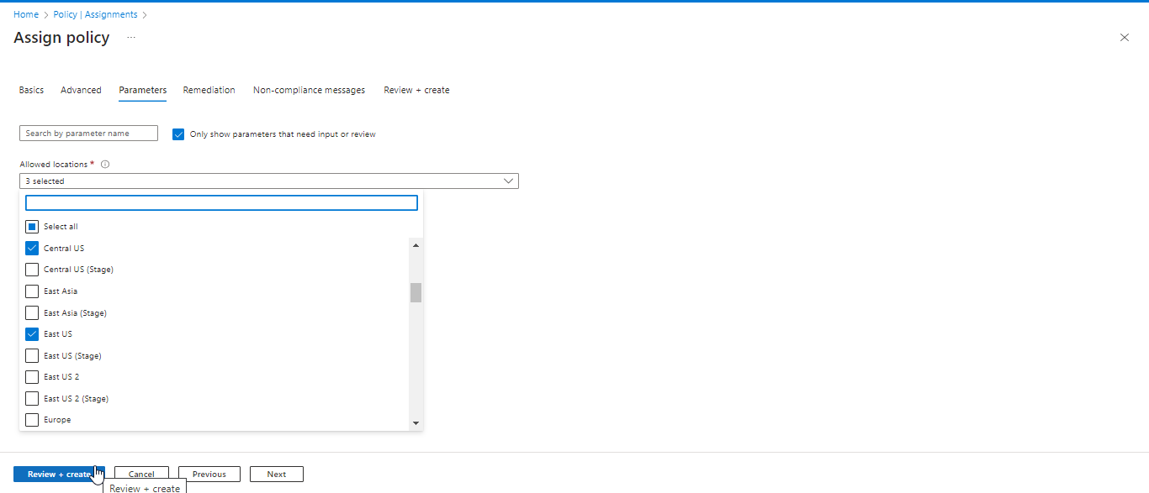

  - Then, click on the Create button

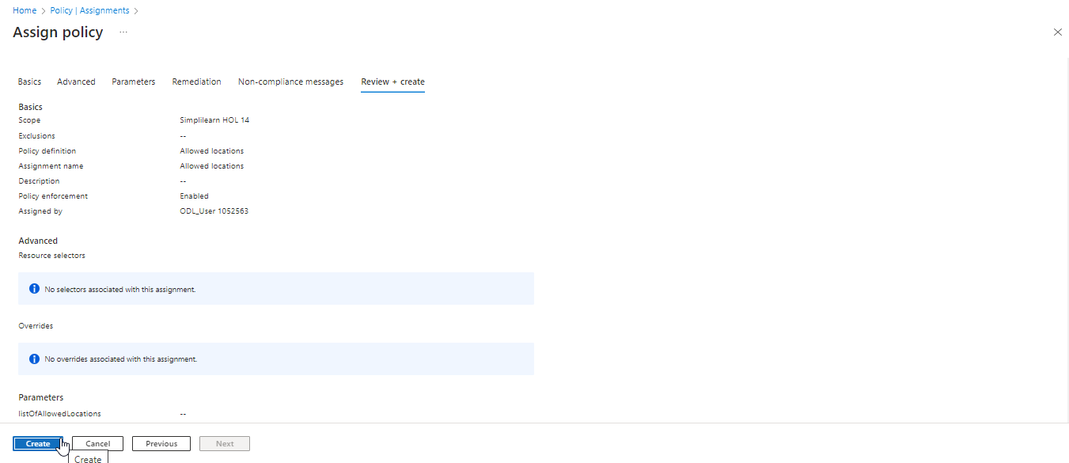

- Once the policy is created, users can view a list of applied policies by clicking on the Allowed locations (policy name) on the Assignments page.

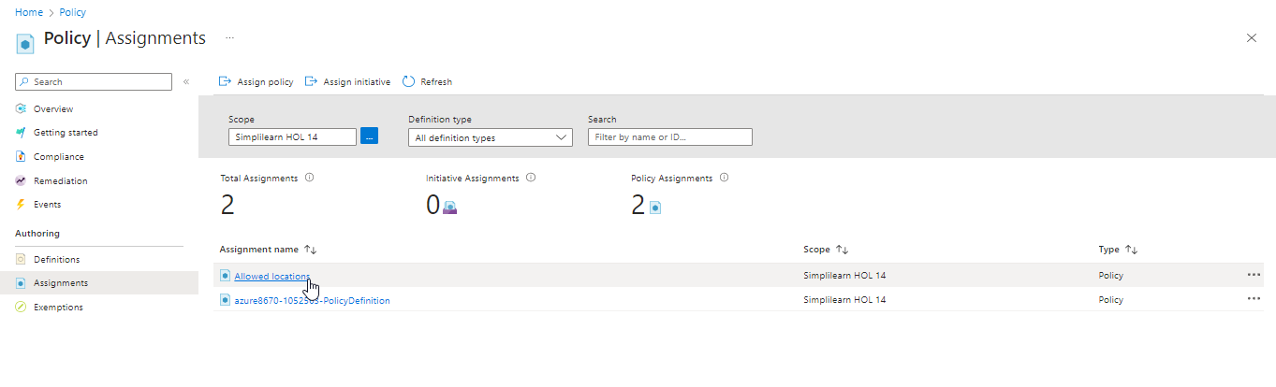

Here, users can access a list of assigned policies and obtain detailed information about each policy by clicking on them.

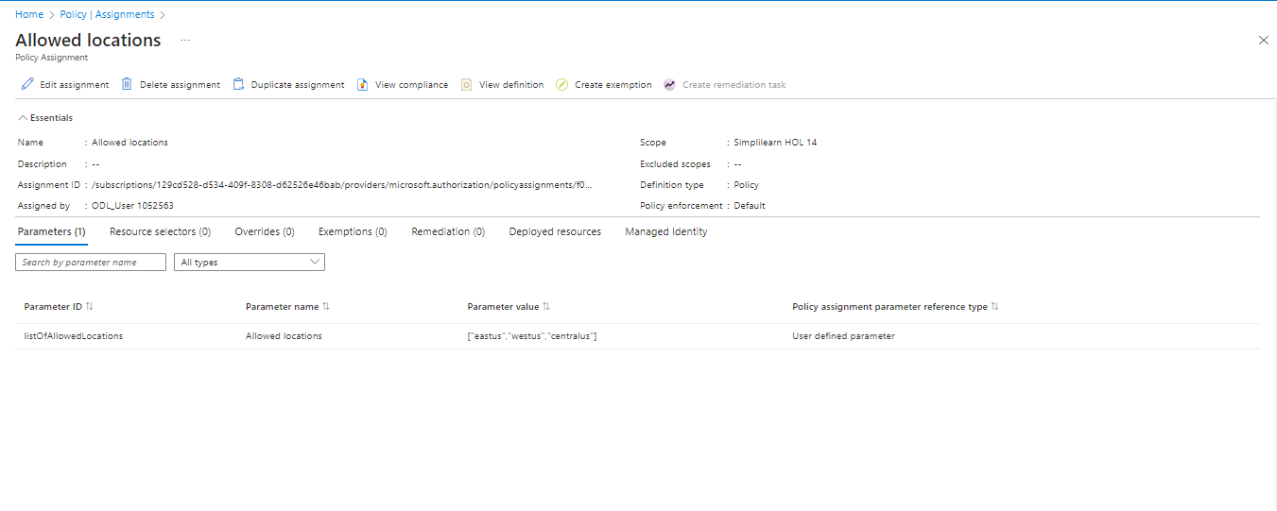

Step 2: Create and assign an initiative definition

  - Return to the Azure portal and select Compliance

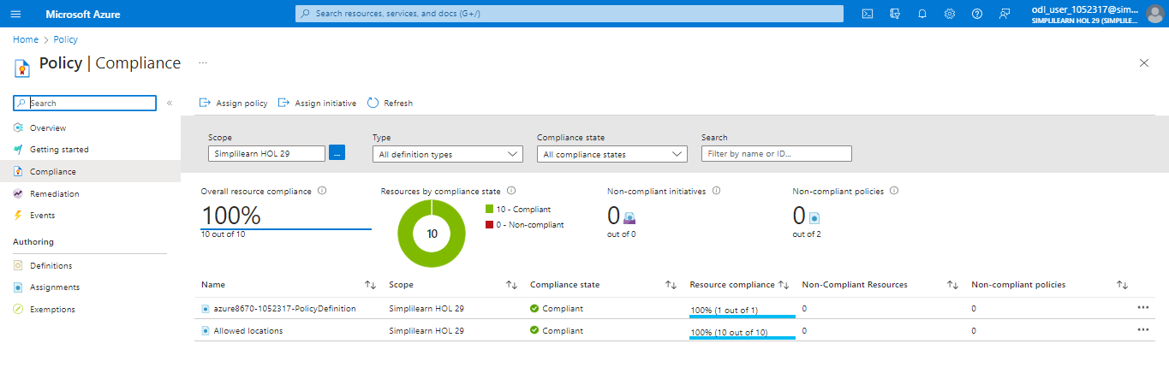

  - Select Definitions and go to Initiative definitions

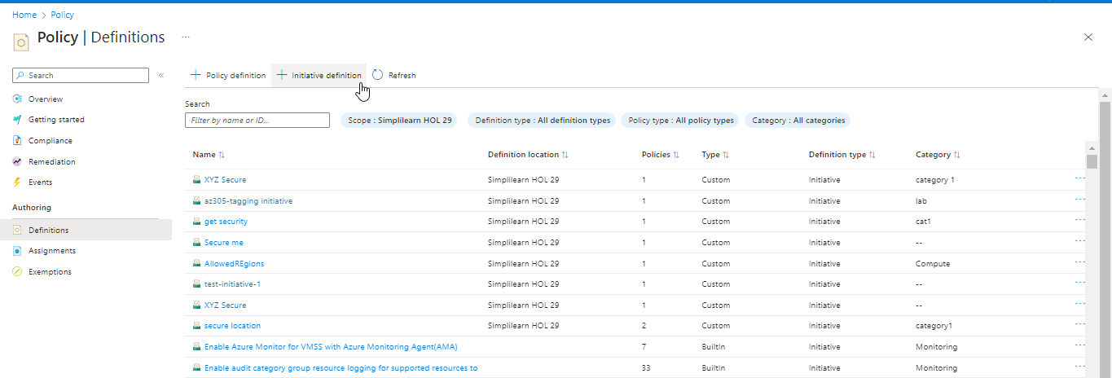

  - Fill out the provided tab and click Next

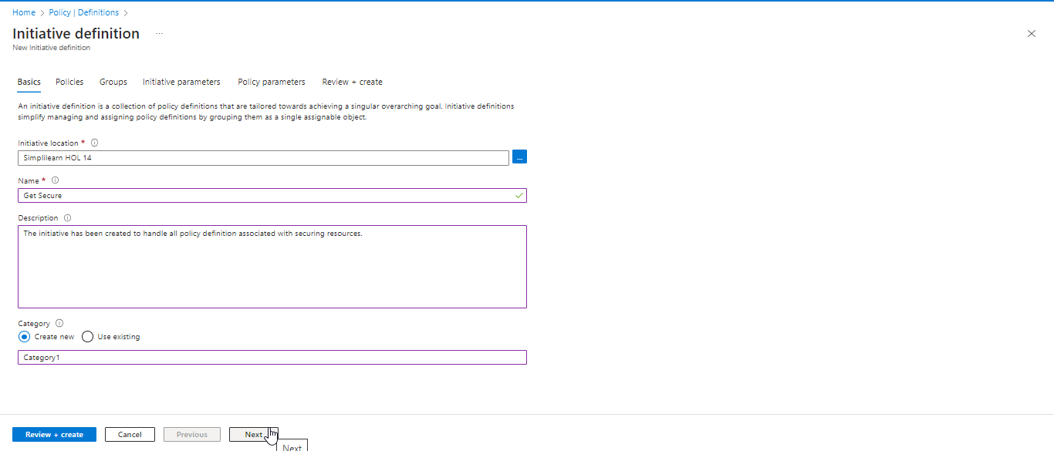

  - Choose policy Allowed locations under Add policy definition(s) and Click Add

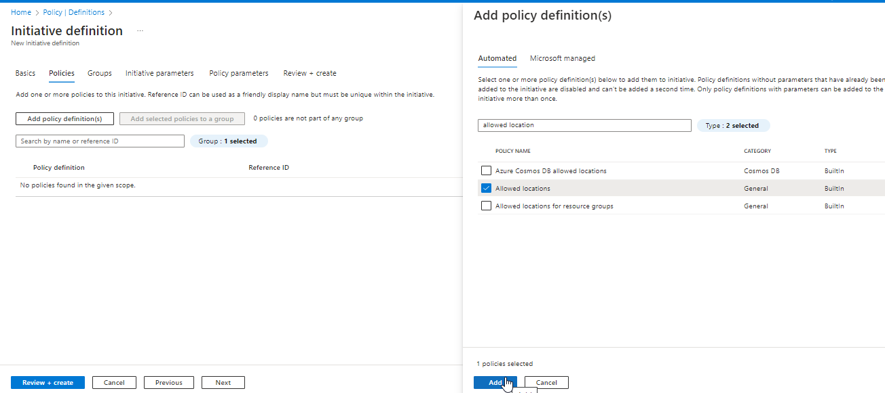

  - Click on Next (twice) and select the desired value(s) for Policy parameters

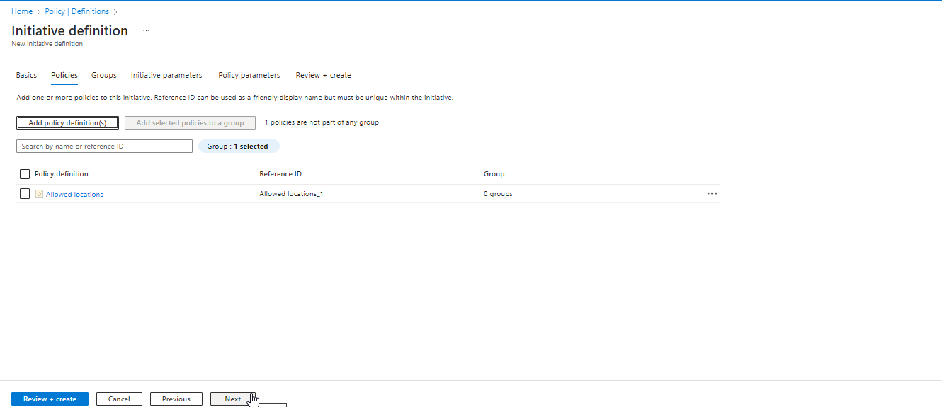

  - Click on Review + create

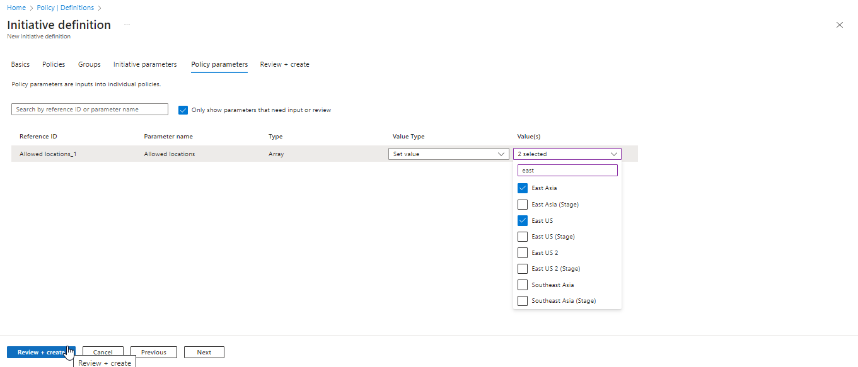

  - Then, click on Create

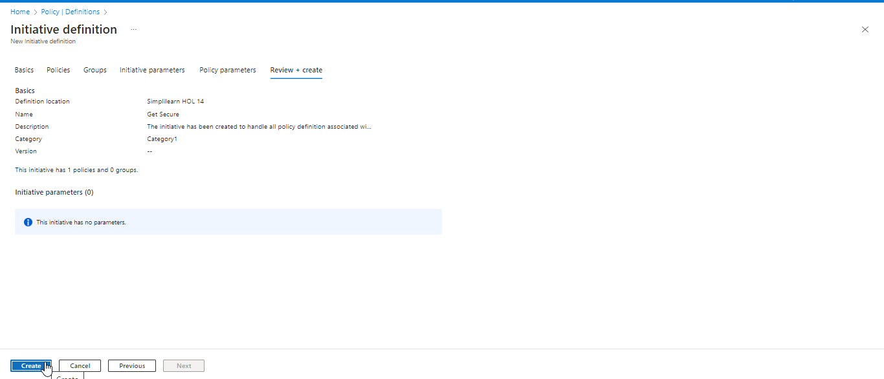

The output as shown below:

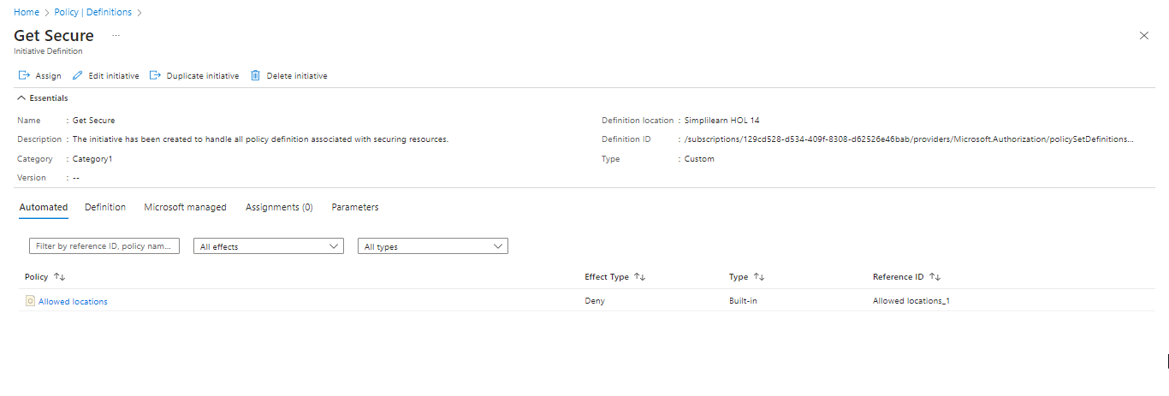

Step 3: Check for compliance

- Return to Policy, then select Compliance to review the status of both the policy and its definition



You have now successfully implemented an Azure policy to enforce compliance and regulatory settings within your organization.

